Name of the Student | N.Jeevan Sai
Reg. No | 192525169
GitHub Link | https://github.com/Nagellajeevansai/MLA0405-Deep-Learning.git

SIMATS ENGINEERING
CO5 - ASSESSMENT TOOL 3

Technical Presentation
COURSE NAME:Deep Learning COURSE CODE:MLA0405 SLOT : D Faculty : Dr.Arul Raj A.M

COURSE OUTCOME COVERED
CO5: Students will be able to analyze and explain advanced generative deep learning models including Autoencoders, Deep Belief Networks, Boltzmann Machines, Deep Boltzmann Machines and Generative Adversarial Networks. They will be able to compare their architectures, explain their learning mechanisms, and apply suitable generative models to realworld problems. (BTL-3)

Course Outcome Weightage: 35% | Duration: 90 minutes
Assessment Tool Weightage: 50% | Mark : 25

Code of Conduct:

I(N.Jeevan Sai / 192525169) certify that this submission is my original work and that I have adhered to the guidelines specified for this assessment.
I understand that any violation of academic integrity rules will result in disciplinary action.

Signature of the student:  Name of the student : N.Jeevan Sai

Criteria | Understanding of Problem Context (2) | Application of Concepts  (3) | ProblemSolving  Approach  (3) | Accuracy of Solution (2) | Clarity (1) | Total  (10)
Weightage | 20 % | 30% | 30% | 20 % | 10 % | 100%
Q1
Total

Signature of the Faculty: Total Marks:
PHOTO : 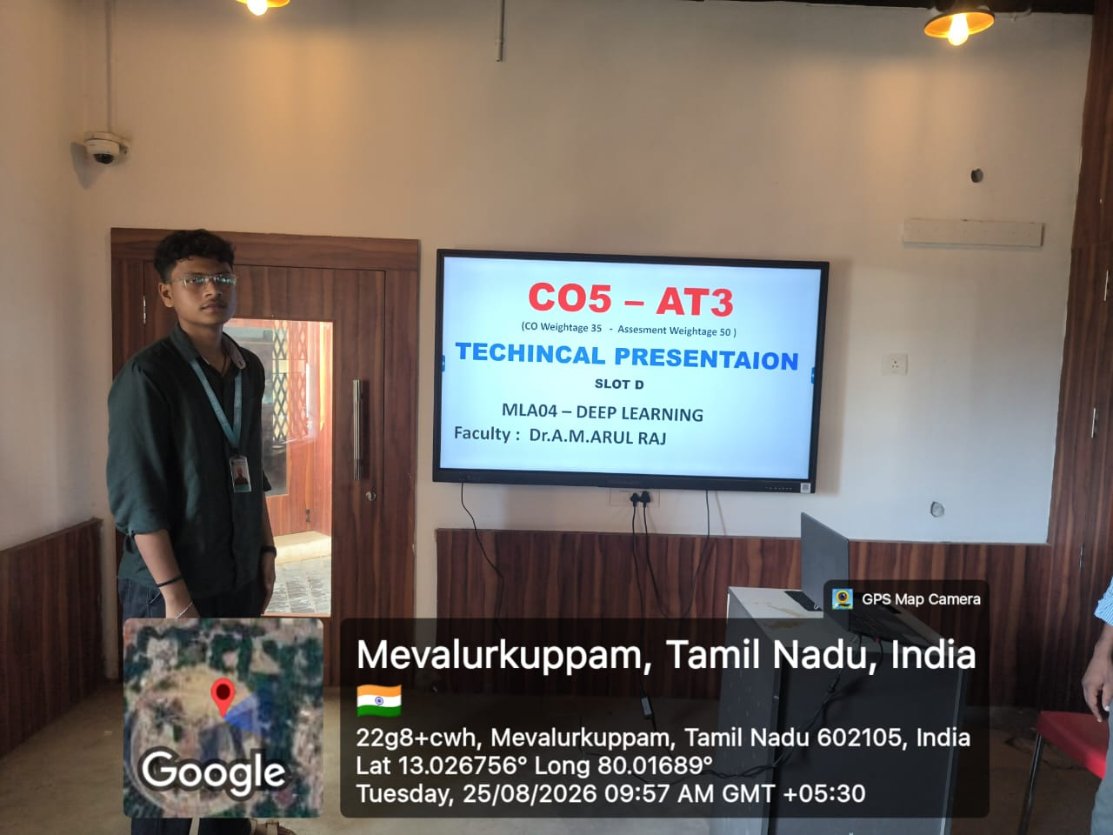

QUESTIONS: Stochastic Encoders, Decoders and Contractive Encoders
Prepare a technical presentation explaining Stochastic Encoders and Decoders and Contractive Encoders. Describe their working principles, objectives, robustness characteristics, and differences from standard autoencoders. Demonstrate a suitable real-world application for each approach.
PRESENTATION ANSWER:
Stochastic Encoders, Decoders and Contractive Encoders Slide 1 – Title
Stochastic Encoders, Decoders and Contractive Encoders
- Advanced Autoencoder Architectures
- Focus: Working Principle, Objectives, Robustness and Applications
Slide 2 – Introduction to Autoencoders
- An Autoencoder (AE) is an unsupervised neural network used to learn compact representations of data.
- It consists of two main components:
  - Encoder: Converts input data into a latent representation.
  - Decoder: Reconstructs the original data from the latent representation.
- Objective: Minimize the difference between input and reconstructed output.
- Standard autoencoders generally learn a deterministic mapping.
Basic flow:
Input → Encoder → Latent Representation → Decoder → Reconstruction
Slide 3 – Stochastic Encoder
- A Stochastic Encoder does not produce a single fixed latent vector.
- Instead, it generates a probability distribution over the latent representation.
- Usually represented using: o Mean: μ o Variance: σ²
- A latent sample is obtained from this distribution.
- This introduces controlled randomness into the encoding process.
Flow:
Input x → Encoder → μ, σ → Sampling → Latent z
Slide 4 – Working of Stochastic Encoder
- Input data is provided to the encoder.
- The neural network extracts important features.
- The encoder produces parameters μ and σ.
- A probability distribution is constructed.
- A latent vector z is sampled from the distribution.
- The sampled vector is passed to the decoder. A common sampling method is the reparameterization trick:
z = μ + σ ⊙ ε where ε is random noise sampled from a standard normal distribution.
Slide 5 – Stochastic Decoder
- A Stochastic Decoder models uncertainty during reconstruction.
- Instead of always producing one fixed output, it can represent a distribution of possible outputs.
- It is useful when multiple outputs are reasonable for the same input.
- The decoder learns the probability distribution of the reconstructed data.
Flow:
Latent z → Stochastic Decoder → Output Distribution → Reconstructed Sample
Slide 6 – Objectives of Stochastic Encoders and Decoders
- Learn meaningful latent representations.
- Model uncertainty in data.
- Generate new and realistic samples.
- Improve generalization.
- Handle noisy or incomplete information.
- Represent complex data distributions.
- Provide more flexible latent spaces than deterministic autoencoders.
Slide 7 – Robustness Characteristics
Stochastic autoencoders can provide robustness through controlled randomness.
- Less dependent on an exact latent representation.
- Can handle variations and noise in input data.
- Encourage smoother latent representations.
- Improve generalization to unseen samples.
- Useful for uncertain and probabilistic environments.
Example:
A slightly noisy image can still produce a meaningful latent representation and reconstructed image.
Slide 8 – Contractive Encoder
- A Contractive Encoder is designed to make the learned representation insensitive to small changes in the input.
- It adds a contractive regularization penalty to the training objective.
- The encoder learns representations that remain stable when the input is slightly perturbed.
- It is particularly useful for learning robust features.
Basic idea:
Small Input Change → Very Small Latent Change
Slide 9 – Working of Contractive Encoder
- Input is passed through the encoder.
- The encoder generates a latent representation.
- The reconstruction error is calculated.
- The sensitivity of the encoder to input changes is measured.
- A contractive penalty is added to the loss.
- The network learns a stable representation.
The objective can be represented as:
Total Loss = Reconstruction Loss + λ × Contractive Penalty
The contractive penalty is commonly based on the Frobenius norm of the encoder Jacobian:
L = Lreconstruction + λ ||Jf(x)||²F where Jf(x) represents how sensitive the encoder representation is to input changes.
Slide 10 – Robustness of Contractive Encoders • Reduces sensitivity to small input perturbations.
- Learns stable and invariant features.
- Helps suppress irrelevant variations.
- Can improve performance with noisy data.
- Produces smoother representations around training examples.
- Useful for pattern recognition and feature extraction.
Slide 11 – Standard vs Stochastic vs Contractive Autoencoder
Feature | Standard AE | Stochastic AE Contractive AE
Latent representation | Deterministic | Probabilistic Deterministic
Randomness | Low/None | Introduced intentionally Low/None
Main objective | Reconstruction | Reconstruction + distribution Reconstruction +  learning stability
Handles uncertainty | Limited | Excellent Limited
Noise robustness | Moderate | Good Good
Main strength | Compression | Generative representation Robust features
Typical use | Dimensionality reduction | Data generation Feature learning

Slide 12 – Real-World Application: Stochastic Autoencoder Application: Medical Image Generation and Reconstruction
- Medical images can contain uncertainty and variations.
- A stochastic encoder learns a probability distribution for image features.
- The decoder can generate different plausible reconstructions.
- Useful for:
o MRI image reconstruction o CT image enhancement o Missing-data reconstruction o Synthetic medical image generation
Example:
A partially corrupted MRI scan can be represented probabilistically and reconstructed into plausible versions.
Slide 13 – Real-World Application: Contractive Autoencoder
Application: Handwritten Character Recognition
- Handwritten characters can vary in size, angle and stroke thickness.
- A contractive encoder learns features that are less sensitive to these small variations.
- The resulting representation focuses on important character structures.
- This can improve classification and recognition.
Example:
Different handwritten versions of the digit “5” can produce similar latent representations even when their strokes differ slightly.
Slide 14 – Advantages
Stochastic Encoders/Decoders
- Model uncertainty effectively.
- Support data generation.
Contractive Encoders
- Learn robust representations.
- Reduce sensitivity to small perturbations.
Slide 15 – Limitations
Stochastic Approach
- Training can be computationally more complex.
- Random sampling can make optimization challenging.
- Requires careful probability-distribution design.
Contractive Approach
- Additional regularization increases training complexity.
- Selecting the regularization parameter λ is important.
- Excessive contraction may remove useful information.
Slide 16 – Conclusion
- Standard Autoencoders mainly focus on reconstructing input data.
- Stochastic Encoders and Decoders introduce probability and uncertainty into representation and reconstruction.
- Contractive Encoders focus on learning representations that are stable against small input variations.
- Stochastic models are especially suitable for generation, uncertainty modeling and reconstruction.
- Contractive models are suitable for robust feature extraction and recognition.

RUBRICS FOR CALCULATION:

Criteria | Weightage | Level 4 Exemplary | Level 3 Proficient | Level 2 Developing | Level 1 Beginning
Understanding of Problem  Context | 20 | Clearly understands the problem and  accurately  identifies all requirements | Good understanding  with minor gaps | Basic understanding; some  requirements unclear | Poor understanding or  misinterpretation of the problem
Application of Concepts | 30 | Accurately applies  appropriate concepts to solve  complex problems | Applies relevant concepts  correctly with minor errors | Applies basic concepts with limited accuracy | Fails to apply appropriate concepts
ProblemSolving  Approach | 20 | Logical, well-  structured,  and efficient approach | Mostly logical approach with minor gaps | Basic approach with some  inconsistencies | Illogical or unclear approach
Accuracy of Solution | 20 | Completely correct  solution  with proper justification | Mostly correct with minor errors | Partially correct solution | Incorrect or incomplete solution
Clarity | 10 | Clear, wellorganized,  and properly  explained solution | Understandable with minor clarity issues | Limited clarity and  explanation | Poorly presented and difficult to understand

